Data Visualization

Digital Assignment - 2

19BCE1612 - Devesh Tibarewal

11 April 2022

#### **Define Multivariate Data.**

Multivariate data analysis is a type of statistical analysis that involves more than two dependent variables, resulting in a single outcome. Many problems in the world can be practical examples of multivariate equations as whatever happens in the world happens due to multiple reasons.

#### **Example of multivariate data with a case study**

All the datasets that contains more than 2 attributes can be considered as Multivariate data like the dataset used in my notebook below.

#### **My Notebook**

##### Importing Necessary Dependencies.

import pandas as pd  
import matplotlib.pyplot as plt  
from mpl_toolkits.mplot3d import Axes3D  
import matplotlib as mpl  
import numpy as np  
import seaborn as sns

##### Loading and merging Dataset.

white_wine = pd.read_csv('winequality-white.csv', sep=';')  
red_wine = pd.read_csv('winequality-red.csv', sep=';')  
  
# store wine type as an attribute  
red_wine['wine_type'] = 'red'   
white_wine['wine_type'] = 'white'  
  
# bucket wine quality scores into qualitative quality labels  
red_wine['quality_label'] = red_wine['quality'].apply(lambda value: 'low'   
 if value <= 5 else 'medium'   
 if value <= 7 else 'high')  
red_wine['quality_label'] = pd.Categorical(red_wine['quality_label'],   
 categories=['low', 'medium', 'high'])  
white_wine['quality_label'] = white_wine['quality'].apply(lambda value: 'low'   
 if value <= 5 else 'medium'   
 if value <= 7 else 'high')  
white_wine['quality_label'] = pd.Categorical(white_wine['quality_label'],   
 categories=['low', 'medium', 'high'])  
  
# merge red and white wine datasets  
wines = pd.concat([red_wine, white_wine])  
  
# re-shuffle records just to randomize data points  
wines = wines.sample(frac=1, random_state=42).reset_index(drop=True)

##### Understand dataset features and values.

wines.head()

## fixed acidity volatile acidity ... wine_type quality_label  
## 0 7.0 0.17 ... white high  
## 1 7.7 0.64 ... red low  
## 2 6.8 0.39 ... white medium  
## 3 6.3 0.28 ... white medium  
## 4 7.4 0.35 ... white medium  
##   
## [5 rows x 14 columns]

##### Exploratory Data Analysis and Visualizations

Descriptive Statistics

subset_attributes = ['residual sugar', 'total sulfur dioxide', 'sulphates', 'alcohol', 'volatile acidity', 'quality']  
rs = round(red_wine[subset_attributes].describe(),2)  
ws = round(white_wine[subset_attributes].describe(),2)  
pd.concat([rs, ws], axis=1, keys=['Red Wine Statistics', 'White Wine Statistics'])

## Red Wine Statistics ... White Wine Statistics   
## residual sugar total sulfur dioxide ... volatile acidity quality  
## count 1599.00 1599.00 ... 4898.00 4898.00  
## mean 2.54 46.47 ... 0.28 5.88  
## std 1.41 32.90 ... 0.10 0.89  
## min 0.90 6.00 ... 0.08 3.00  
## 25% 1.90 22.00 ... 0.21 5.00  
## 50% 2.20 38.00 ... 0.26 6.00  
## 75% 2.60 62.00 ... 0.32 6.00  
## max 15.50 289.00 ... 1.10 9.00  
##   
## [8 rows x 12 columns]

subset_attributes = ['alcohol', 'volatile acidity', 'pH', 'quality']  
ls = round(wines[wines['quality_label'] == 'low'][subset_attributes].describe(),2)  
ms = round(wines[wines['quality_label'] == 'medium'][subset_attributes].describe(),2)  
hs = round(wines[wines['quality_label'] == 'high'][subset_attributes].describe(),2)  
pd.concat([ls, ms, hs], axis=1, keys=['Low Quality Wine', 'Medium Quality Wine', 'High Quality Wine'])

## Low Quality Wine ... High Quality Wine   
## alcohol volatile acidity ... pH quality  
## count 2384.00 2384.00 ... 198.00 198.00  
## mean 9.87 0.40 ... 3.23 8.03  
## std 0.84 0.19 ... 0.16 0.16  
## min 8.00 0.10 ... 2.88 8.00  
## 25% 9.30 0.26 ... 3.13 8.00  
## 50% 9.60 0.34 ... 3.23 8.00  
## 75% 10.40 0.50 ... 3.33 8.00  
## max 14.90 1.58 ... 3.72 9.00  
##   
## [8 rows x 12 columns]

##### Multivariate Analysis

##### Visualizing two dimensions

f, ax = plt.subplots(figsize=(10, 6))  
corr = wines.corr()  
hm = sns.heatmap(round(corr,2), annot=True, ax=ax, cmap="coolwarm",fmt='.2f',  
 linewidths=.05)  
f.subplots_adjust(top=0.93)  
t = f.suptitle('Wine Attributes Correlation Heatmap', fontsize=14)  
plt.show()

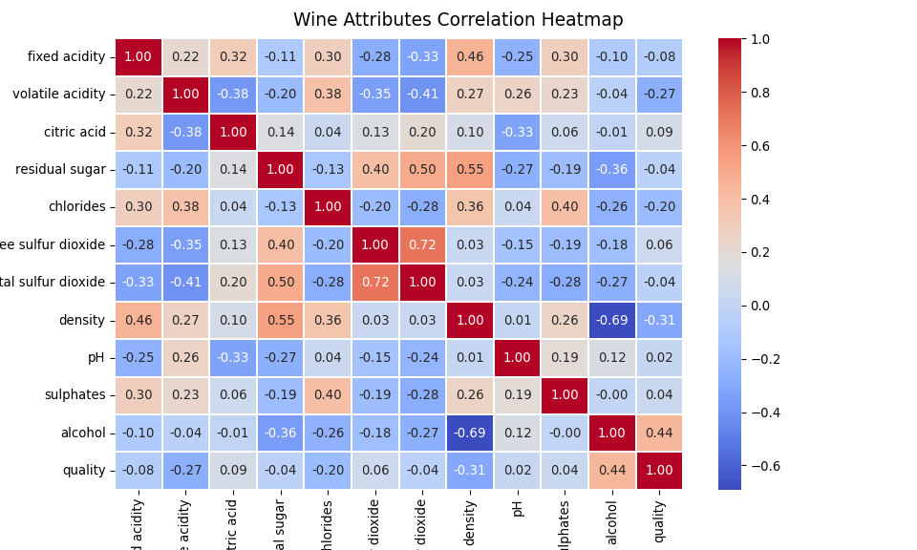

##### Inference:

The gradients in the heatmap vary based on the strength of the correlation and you can clearly see it is very easy to spot potential attributes having strong correlations amongst themselves. Another way to visualize the same is to use pair-wise scatter plots amongst attributes of interest.

cols = ['density', 'residual sugar', 'total sulfur dioxide', 'fixed acidity']  
pp = sns.pairplot(wines[cols], height=1.8, aspect=1.8,  
 plot_kws=dict(edgecolor="k", linewidth=0.5),  
 diag_kind="kde", diag_kws=dict(shade=True))  
  
fig = pp.fig   
fig.subplots_adjust(top=0.93, wspace=0.3)  
t = fig.suptitle('Wine Attributes Pairwise Plots', fontsize=14)  
plt.show()

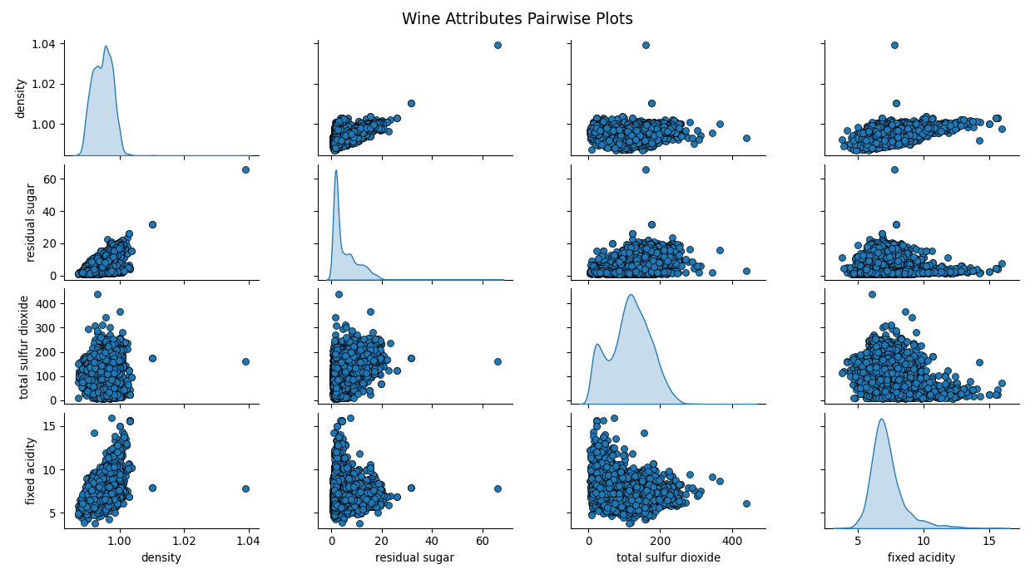

##### Inference:

Based on the above plot, you can see that scatter plots are also a decent way of observing potential relationships or patterns in two-dimensions for data attributes.

cols = ['density', 'residual sugar', 'total sulfur dioxide', 'fixed acidity']  
subset_df = wines[cols]  
  
from sklearn.preprocessing import StandardScaler  
  
ss = StandardScaler()  
scaled_df = ss.fit_transform(subset_df)  
scaled_df = pd.DataFrame(scaled_df, columns=cols)  
final_df = pd.concat([scaled_df, wines['wine_type']], axis=1)  
final_df.head()

## density residual sugar total sulfur dioxide fixed acidity wine_type  
## 0 -0.165631 1.546371 0.181456 -0.166089 white  
## 1 0.301278 -0.681719 0.305311 0.373895 red  
## 2 -0.859324 0.411306 0.305311 -0.320370 white  
## 3 0.408001 1.210056 1.189993 -0.706073 white  
## 4 1.395180 1.777588 2.003900 0.142473 white

from pandas.plotting import parallel_coordinates  
f = plt.figure()  
pc = parallel_coordinates(final_df, 'wine_type', color=('#FFE888', '#FF9999'))  
plt.show()

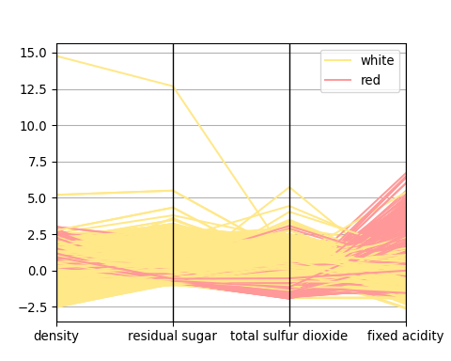

##### Inference:

Basically, in this visualization as depicted above, points are represented as connected line segments. Each vertical line represents one data attribute. One complete set of connected line segments across all the attributes represents one data point. Hence points that tend to cluster will appear closer together. Just by looking at it, we can clearly see that density is slightly more for red wines as compared to white wines. Also residual sugar and total sulfur dioxide is higher for white wines as compared to red and fixed acidity is higher for red wines as compared to white wines.

##### Two Continuous Numeric attributes

f = plt.figure()  
plt.scatter(wines['sulphates'], wines['alcohol'], alpha=0.4, edgecolors='w')  
plt.xlabel('Sulphates')  
plt.ylabel('Alcohol')  
plt.title('Wine Sulphates - Alcohol Content',y=1.05)  
plt.show()

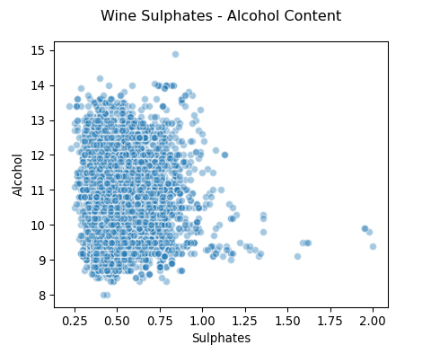

f = plt.figure()  
jp = sns.jointplot(x='sulphates', y='alcohol', data=wines, kind='reg', space=0, height=5, ratio=4)  
plt.show()

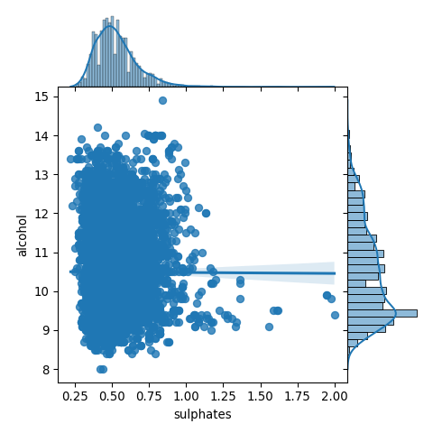

##### Inference:

The scatter plot is depicted on the left side and the joint plot on the right in the above figure. Like we mentioned, you can check out correlations, relationships as well as individual distributions in the joint plot.

##### Two Discrete Categorical attributes

fig = plt.figure(figsize = (10, 4))  
title = fig.suptitle("Wine Type - Quality", fontsize=14)  
fig.subplots_adjust(top=0.85, wspace=0.3)  
  
ax1 = fig.add_subplot(1,2, 1)  
ax1.set_title("Red Wine")  
ax1.set_xlabel("Quality")  
ax1.set_ylabel("Frequency")   
rw_q = red_wine['quality'].value_counts()  
rw_q = (list(rw_q.index), list(rw_q.values))  
ax1.set_ylim([0, 2500])

## (0.0, 2500.0)

ax1.tick_params(axis='both', which='major', labelsize=8.5)  
bar1 = ax1.bar(rw_q[0], rw_q[1], color='red',   
 edgecolor='black', linewidth=1)  
  
  
ax2 = fig.add_subplot(1,2, 2)  
ax2.set_title("White Wine")  
ax2.set_xlabel("Quality")  
ax2.set_ylabel("Frequency")   
ww_q = white_wine['quality'].value_counts()  
ww_q = (list(ww_q.index), list(ww_q.values))  
ax2.set_ylim([0, 2500])

## (0.0, 2500.0)

ax2.tick_params(axis='both', which='major', labelsize=8.5)  
bar2 = ax2.bar(ww_q[0], ww_q[1], color='white',   
 edgecolor='black', linewidth=1)  
plt.show()

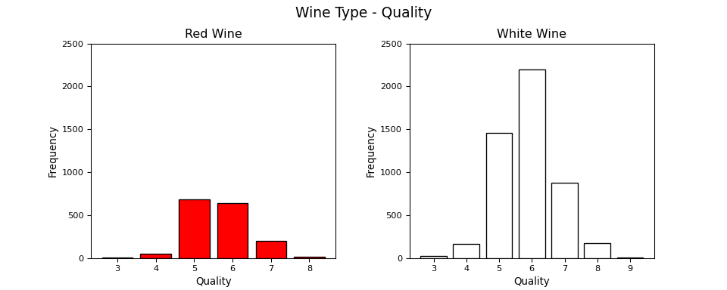

While this is a good way to visualize categorical data, as you can see, leveraging matplotlib has resulted in writing a lot of code. Another good way is to use stacked bars or multiple bars for the different attributes in a single plot. We can leverage seaborn for the same easily.

f = plt.figure()  
cp = sns.countplot(x="quality", hue="wine_type", data=wines, palette={"red": "#FF9999", "white": "#FFE888"})  
plt.show()

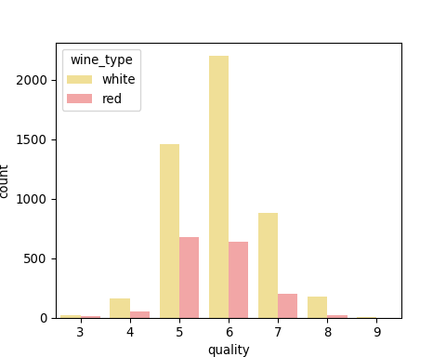

This definitely looks cleaner and you can also effectively compare the different categories easily from this single plot.

##### Mixed attributes (numeric & categorical)

fig = plt.figure(figsize = (10,4))  
title = fig.suptitle("Sulphates Content in Wine", fontsize=14)  
fig.subplots_adjust(top=0.85, wspace=0.3)  
  
ax1 = fig.add_subplot(1,2, 1)  
ax1.set_title("Red Wine")  
ax1.set_xlabel("Sulphates")  
ax1.set_ylabel("Frequency")   
ax1.set_ylim([0, 1200])

## (0.0, 1200.0)

ax1.text(1.2, 800, r'$\mu$='+str(round(red_wine['sulphates'].mean(),2)),   
 fontsize=12)  
r_freq, r_bins, r_patches = ax1.hist(red_wine['sulphates'], color='red', bins=15,  
 edgecolor='black', linewidth=1)  
  
ax2 = fig.add_subplot(1,2, 2)  
ax2.set_title("White Wine")  
ax2.set_xlabel("Sulphates")  
ax2.set_ylabel("Frequency")  
ax2.set_ylim([0, 1200])

## (0.0, 1200.0)

ax2.text(0.8, 800, r'$\mu$='+str(round(white_wine['sulphates'].mean(),2)),   
 fontsize=12)  
w_freq, w_bins, w_patches = ax2.hist(white_wine['sulphates'], color='white', bins=15,  
 edgecolor='black', linewidth=1)  
plt.show()

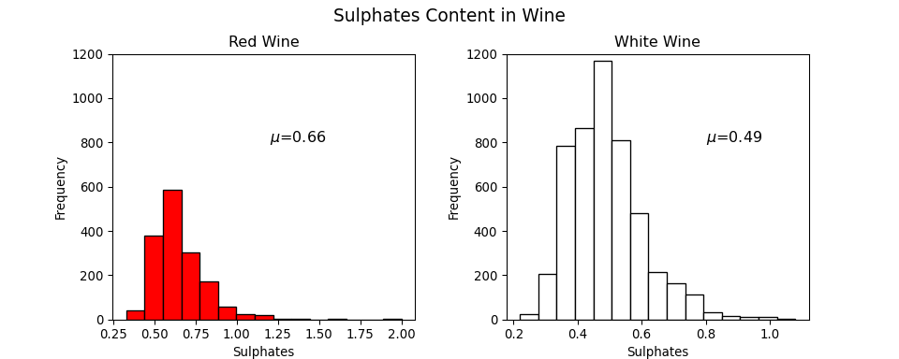

fig = plt.figure(figsize = (10, 4))  
title = fig.suptitle("Sulphates Content in Wine", fontsize=14)  
fig.subplots_adjust(top=0.85, wspace=0.3)  
  
ax1 = fig.add_subplot(1,2, 1)  
ax1.set_title("Red Wine")  
ax1.set_xlabel("Sulphates")  
ax1.set_ylabel("Density")   
sns.kdeplot(red_wine['sulphates'], ax=ax1, shade=True, color='r')  
  
ax2 = fig.add_subplot(1,2, 2)  
ax2.set_title("White Wine")  
ax2.set_xlabel("Sulphates")  
ax2.set_ylabel("Density")   
sns.kdeplot(white_wine['sulphates'], ax=ax2, shade=True, color='y')  
plt.show()

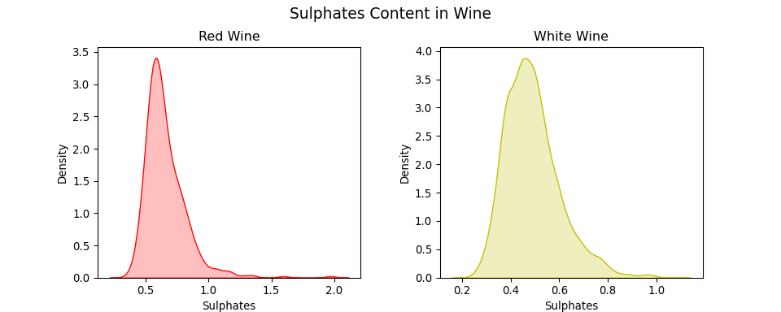

fig = plt.figure(figsize = (6, 4))  
title = fig.suptitle("Sulphates Content in Wine", fontsize=14)  
fig.subplots_adjust(top=0.85, wspace=0.3)  
ax = fig.add_subplot(1,1, 1)  
ax.set_xlabel("Sulphates")  
ax.set_ylabel("Frequency")   
  
g = sns.FacetGrid(wines, hue='wine_type', palette={"red": "r", "white": "y"})  
g.map(sns.distplot, 'sulphates', kde=False, bins=15, ax=ax)

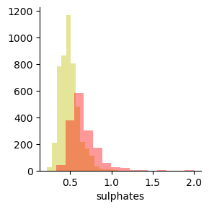

ax.legend(title='Wine Type')  
plt.show()

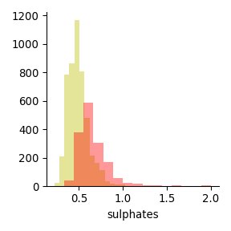

f, (ax) = plt.subplots(1, 1, figsize=(12, 4))  
f.suptitle('Wine Quality - Alcohol Content', fontsize=14)  
  
sns.boxplot(x="quality", y="alcohol", data=wines, ax=ax)  
ax.set_xlabel("Wine Quality",size = 12,alpha=0.8)  
ax.set_ylabel("Wine Alcohol %",size = 12,alpha=0.8)  
plt.show()

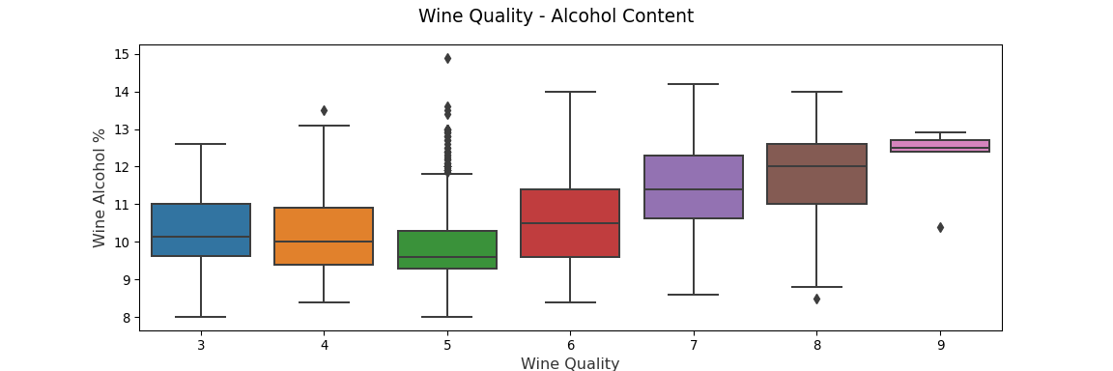

f, (ax) = plt.subplots(1, 1, figsize=(12, 4))  
f.suptitle('Wine Quality - Sulphates Content', fontsize=14)  
  
sns.violinplot(x="quality", y="sulphates", data=wines, ax=ax)  
ax.set_xlabel("Wine Quality",size = 12,alpha=0.8)  
ax.set_ylabel("Wine Sulphates",size = 12,alpha=0.8)  
plt.show()

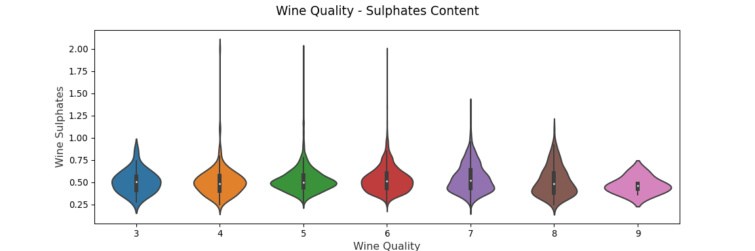

#### **Results**

Above notebook are some types of graphs which are used to visualize multivariate dataset. The Notebook can be accessed this [Github Link](https://github.com/MIstakenGem3017/CSE3020---Data-Visualization/tree/main/Digital%20Assignment%202)

#### **Conclusion**

This experiment enables us to understand and learn some effective strategies for visualizing data especially when the number of dimensions start to increase i.e. if we have a multivariate dataset.